Opening of a new account requires a minimum order of $5,000.
I. COMPANY INFORMATION
Country:
Store Name:
DBA Name:
(Doing Business As)
Address:
Phone Number:
Email Address:
Website Address – URL:
(Non-Transactional)
Please check the box for your retailer type and include the number of store locations.
Department Store |  | Number of Location:
Chain Store |  | Number of Location:
Independent Retailer |  | Number of Location:
Online Store |  | https//:
Type of Store:
Ready - To - Wear |  | Intimate Apparel/Lingerie |  |  | Hosiery
Other (Please Specify)
II. CONTACT INFORMATION
Owner’s Name
Phone Number
Email Address
Manager’s Name
Phone Number
Email Address
Buyer’s Name
Phone Number
Email Address
III. CORE BUSINESS
1. List your top 5 retail brands.
1.
2.
3.
4.
5.
2. Merchandise Category Carried. Mark “X” if you carry any of these categories.
Missy Apparel
Contemporary Apparel
Designer/Couture
Denim
Lingerie
Hosiery
Swim
Active Wear
Shoes
Bridal
Maternity
Plus Size
3. Provide a brief overview of your customer profile.
Gender  (Check Box) | Age |  | Income Level  (Low – Mid – High) | Brand Preferences
Male
Female

IV. STORE IMAGE REQUIREMENTS
As part of the application process, you are required to provide pictures of your boutique. Your application will not be considered for approval, unless boutique images are provided. | Checklist of Required Images:  Store Exterior with Sign  Store Interior  Photo of area where you plan to merchandise  If Online, link of the website  _______________________________________

V. BRANDS INTERESTED IN
FOUNDATION:
 |  | 
 |  |  | 
SHAPEWEAR:
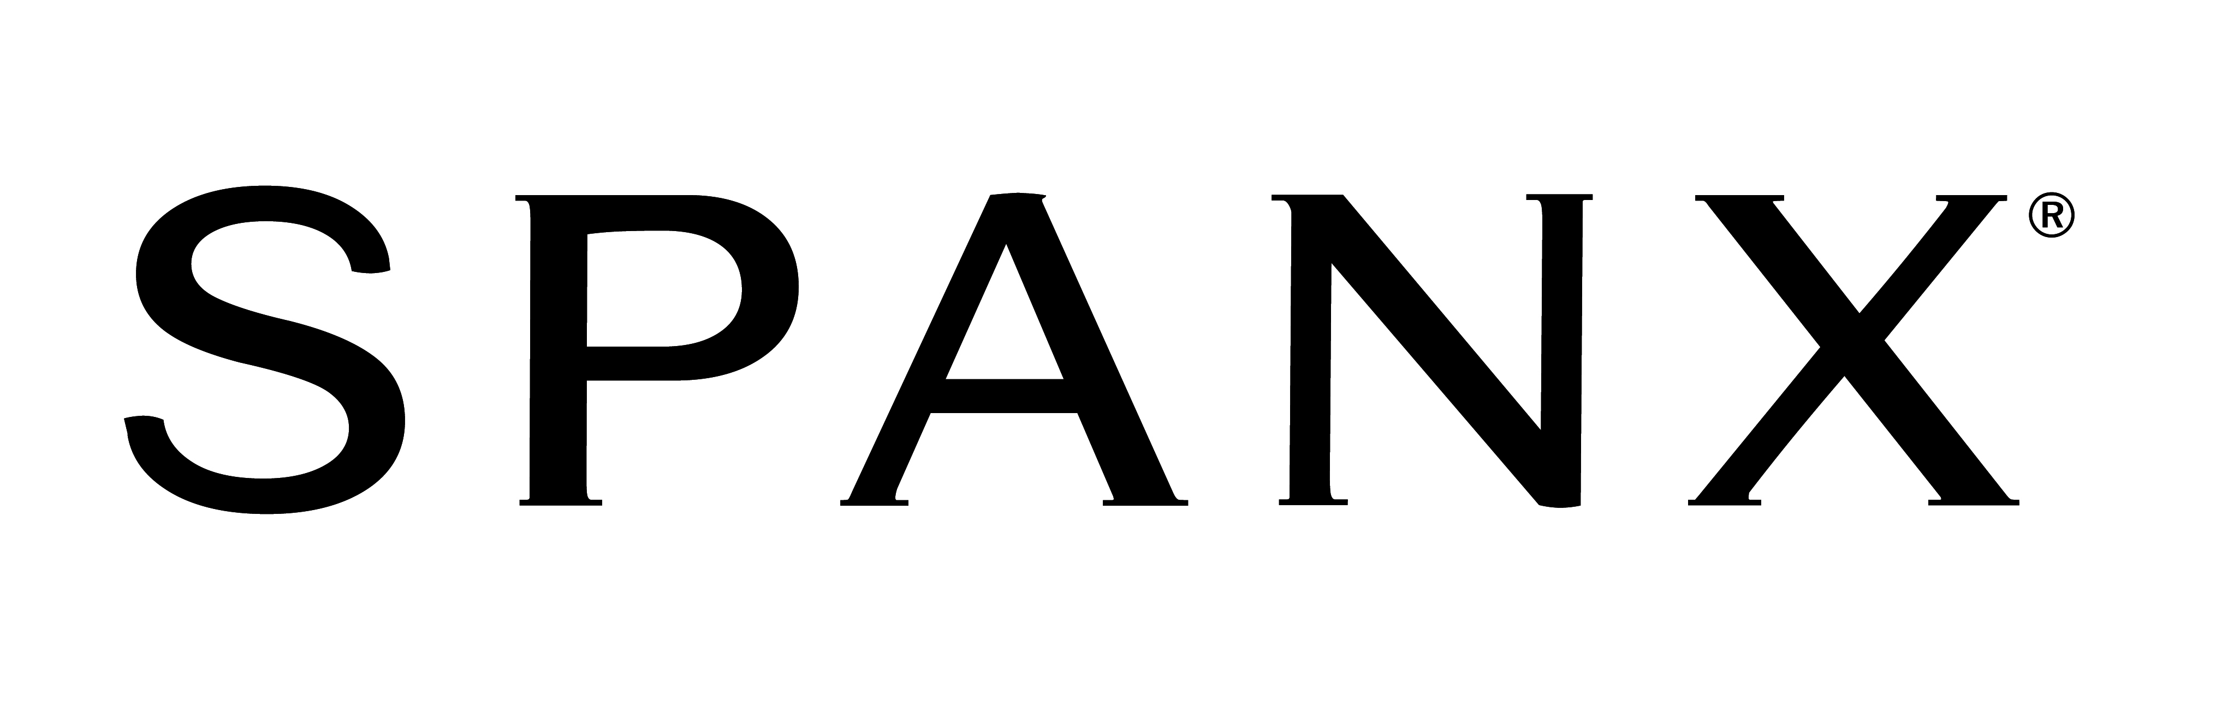 |  | 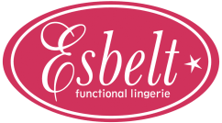
FASHION SOLUTIONS:
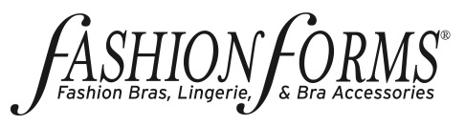 | 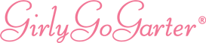
BRIDAL:
 | 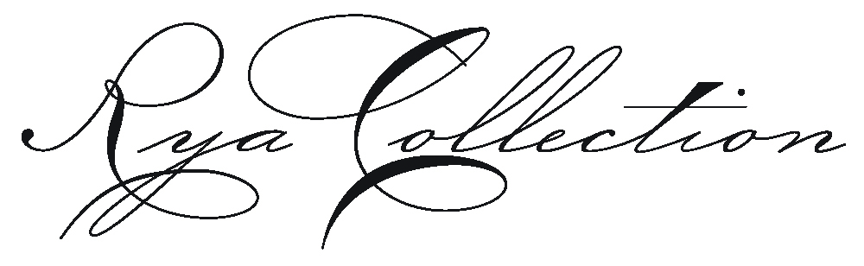 |  | 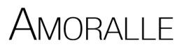

FASHION SOLUTIONS:
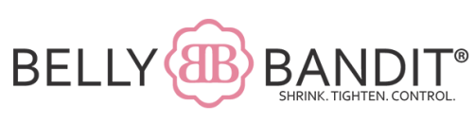
SEDUCTIVE:
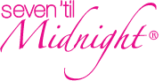 | 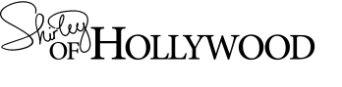
SWIMWEAR:
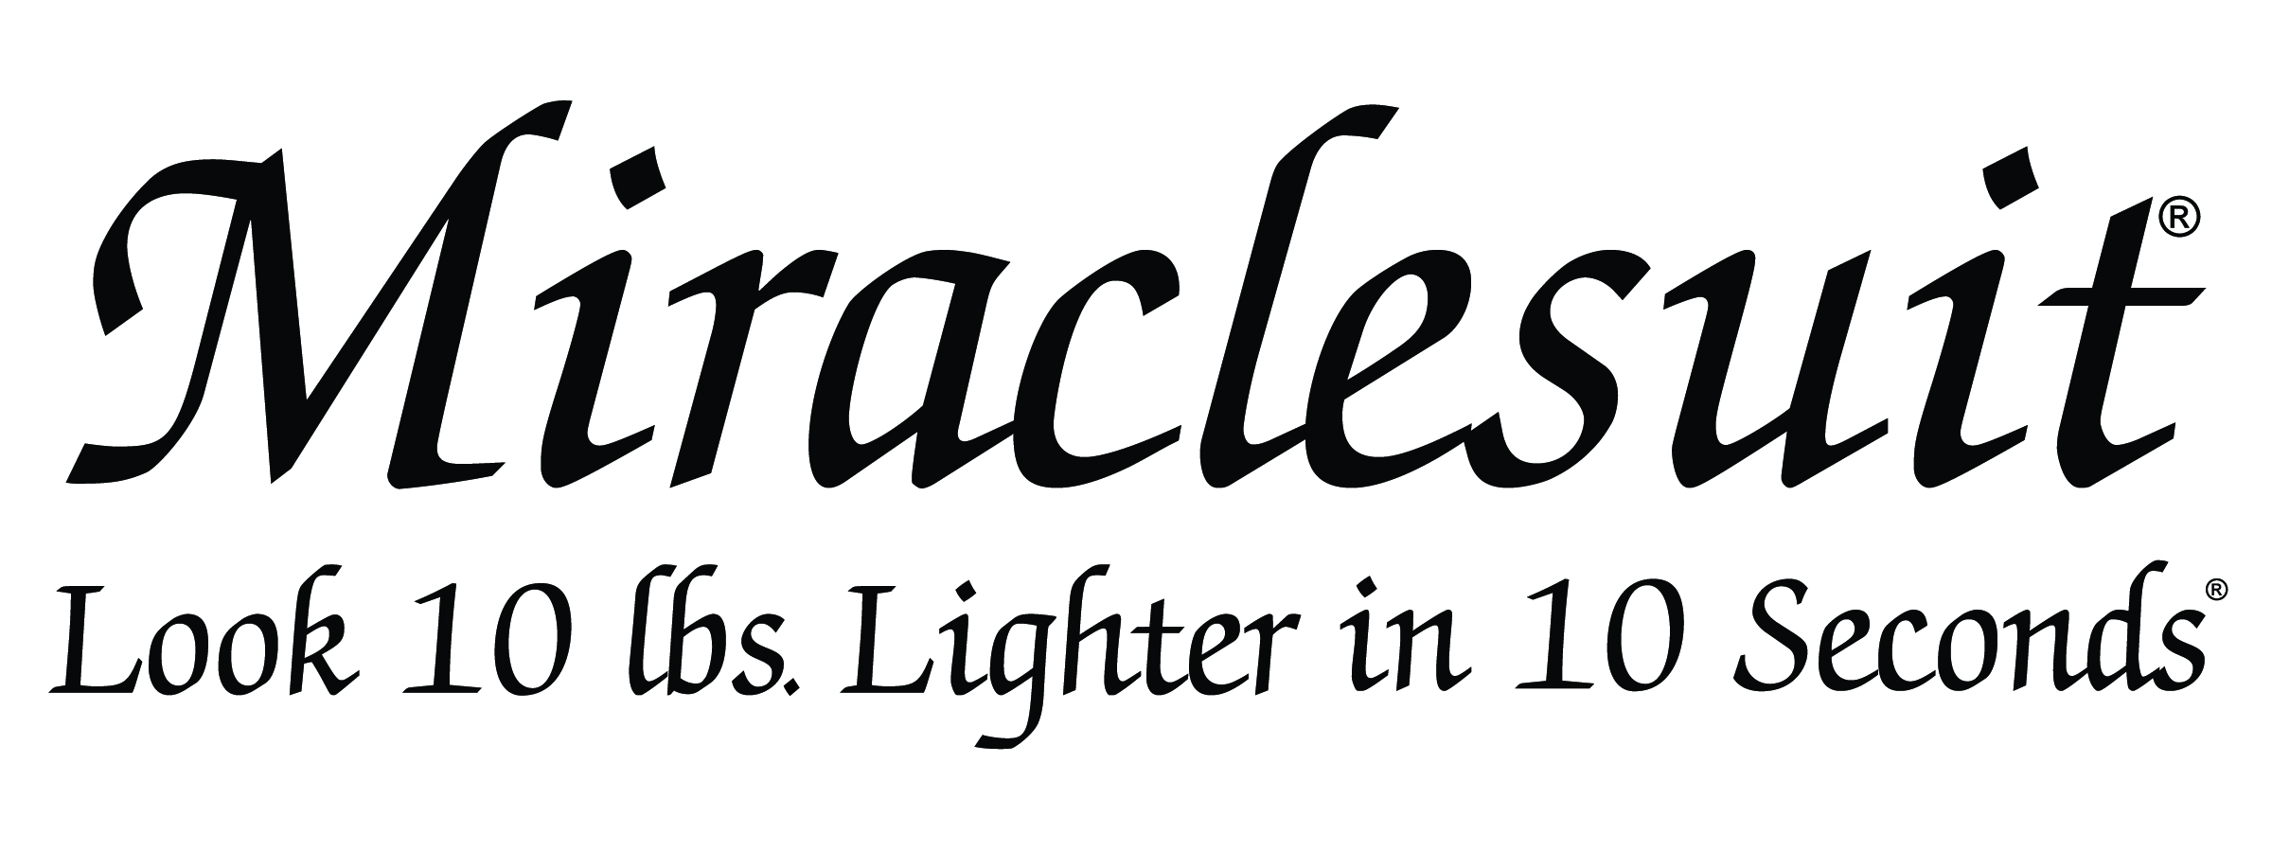 | 
READY-TO-WEAR:
Prepared By:
Date:

